YT-DLP: The Complete Guide (2023)
 BY DIEGO ASTURIAS

MARCH 20, 2023 • LAST UPDATED ON MARCH 13, 2023
#downloader #yt-dlp
Looking for a powerful video downloader? Look no further than yt-dlp! This fantastic tool is packed with features and capabilities for downloading videos from, not only Youtube, but also various video sites.
Yt-dlp is a must-have if you are a serious downloader!
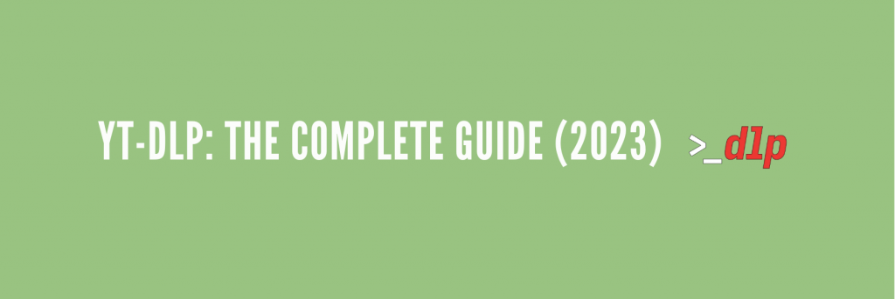
In this guide, we will explore what yt-dlp is and how to download and install it on your Windows or Linux machine. We’ll also cover the necessary dependencies, including FFmpeg, and walk through how to use yt-dlp to download videos.
Whether you’re a beginner or an experienced user, this guide will provide all the information you need to start with yt-dlp.

Table of Contents.
- What is yt-dlp?
- How to download and install YT-DLP?
- Installing Dependencies: FFmpeg and FFProbe
- How to use YT-DLP in Windows and Linux.
- Advanced uses for Plugin yt-dlp.
- yt-dlp: Pros and Cons
- FAQ: yt-dlp
- Final Words.

1. What is yt-dlp?
YT-DLP is a free and open-source software project created (as a fork) from the now-discontinued project, youtube-dlc. yt-dlp is based on the popular YouTube downloader, youtube-dlc, but now comes with additional features and improvements. This software is basically used to download videos from YouTube, Vimeo, and other similar websites.
Downloading and installing yt-dlp is relatively easy, but learning how to use it properly, can take some time. YT-DLP is a command-line tool used on Windows, macOS, and Linux operating systems. Having no “beautiful” front-end GUI puts many people off, yet it is the most potent youtube downloader available.

What are YT-DLP’s main features?
- Network Options: Change how yt-dlp communicates with the network. This includes options such as setting a proxy, adjusting the timeout value, and specifying the user agent string.
- Bypass Geo Restriction: This feature allows you to bypass geographical restrictions that may prevent you from accessing specific videos based on location. You can use yt-dlp options with a VPN or a proxy to get around these restrictions.
- Video Selection: With yt-dlp, you can select the videos you want to download from a playlist or channel. In addition, you can also download entire playlists and channels.
- Download Options: This feature allows you to control the downloading process. You can, for example, choose to download only audio, only video, or both. You can also set the video quality and download speed limits.
- Filesystem Options: With this feature, you can specify the output directory and filename templates for downloaded videos.
- Thumbnail Images: Download thumbnail images for videos along with the video itself. You can even specify the image format and size.
- Workarounds: This feature provides various workarounds for issues arising during the download process. For example, you can use the –no-check-certificate option to bypass SSL certificate verification.
- Automatic retries for failed downloads. By default, yt-dlp will make three attempts to download a video before giving up and moving on to the next one. You can also configure this number of retries.
- Video Format Options: Yt-dlp lets you choose the video format you want to download, such as MP4, WebM, or FLV. You can also set the video quality and resolution.
- Subtitle Features: This yt-dlp option allows you to download subtitles (embed them) along with the video. You can specify the subtitle format and language.
- Authentication Options: Authenticate with certain websites, such as YouTube or Vimeo. You can use options such as username and password or API key to authenticate.
- Post-processing Options: Perform various post-processing tasks on downloaded videos, such as merging or splitting video files, adding metadata, or converting the video to a different format.
- Integrates with SponsorBlock: This feature enables you to mark/remove sponsor sections in YouTube videos through the SponsorBlock API.

2. How to download and install YT-DLP?
- Go to yt-dlp official GitHub repository: https://github.com/yt-dlp/yt-dlp
- Scroll down to the bottom of the page where the download button is visible. This is an internal (anchor) link that will take you to: https://github.com/yt-dlp/yt-dlp#installation.
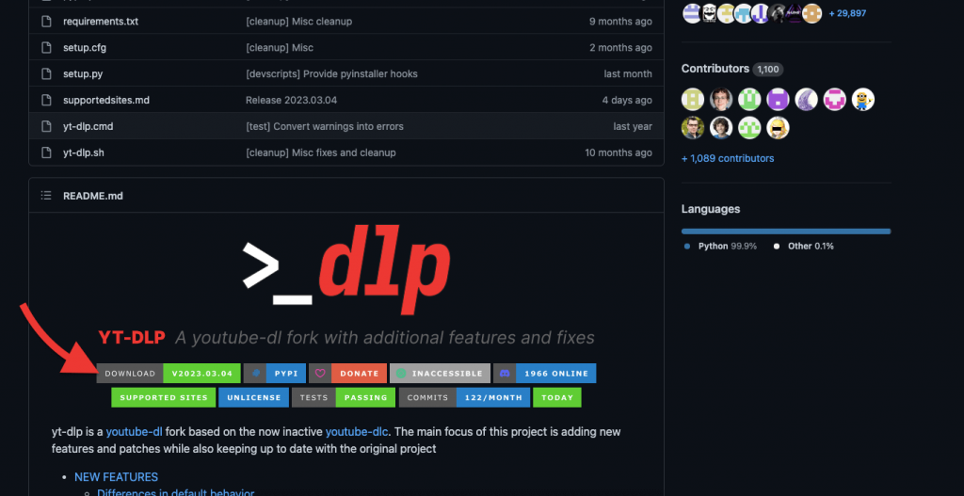
- On this installation page, scroll down and find the latest release files. Locate the executable files, yt-dlp (zip import binary recommended for Linux or BSD), yt-dlp.exe (for Windows), or yt-dlp_macOS (for Windows). If your OS does not support any of these release files, scroll down on this page ‘alternatives’ to find more options.
- Choose your platform or Operating system and download the appropriate release file.
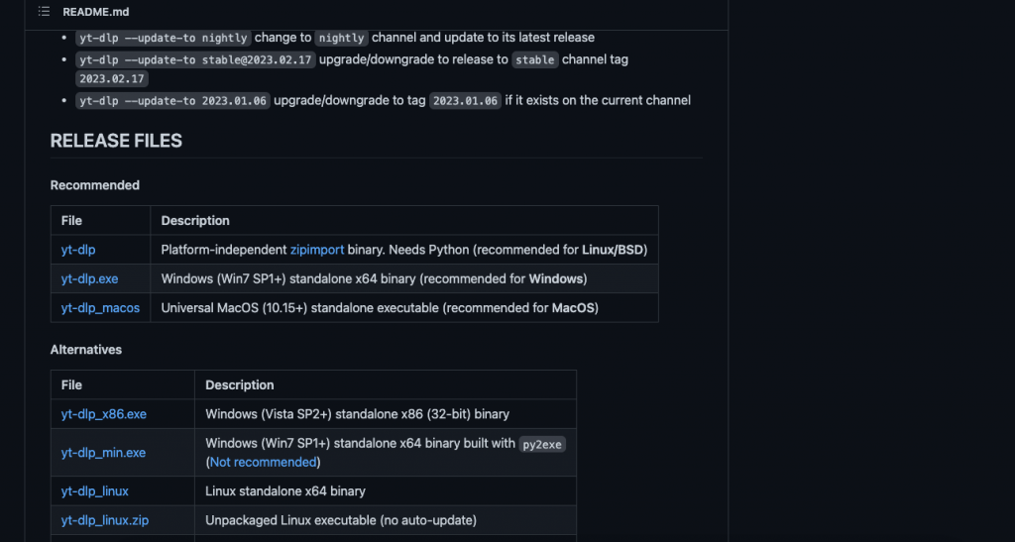

a. Downloading and Installing yt-dlp on Windows.
- For illustration purposes, we will download and install yt-dlp.exe for a windows 2022 Server.
- Once downloaded, verify the size, version, and company, and go ahead and double-click on this .exe file.
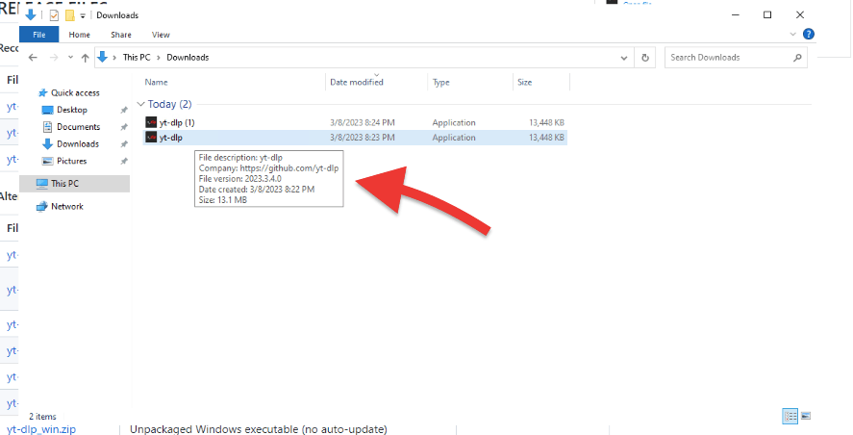
- As long as you have administrator permissions, double-clicking on this executable file will install yt-dlp on your computer.

b. Downloading and Installing yt-dlp in Linux (Ubuntu).
- For illustration purposes, we will download and install the latest release of yt-dlp in Ubuntu 22.04. Ensure your Ubuntu machine is up to date.
- The following command downloads the latest release of the yt-dlp program from GitHub and installs it in the /usr/local/bin directory with the filename yt-dlp.
1 | $ sudo wget https://github.com/yt-dlp/yt-dlp/releases/latest/download/yt-dlp -O /usr/local/bin/yt-dlp

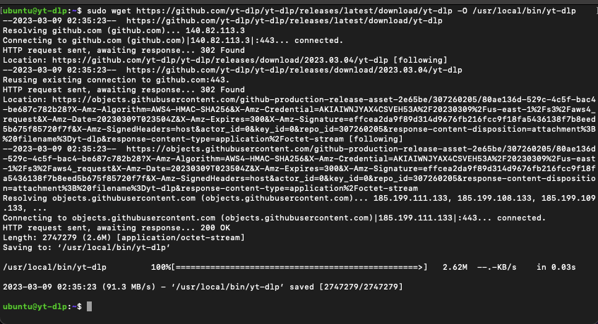
- The following command sets the permissions of the yt-dlp file in the /usr/local/bin directory to allow all users (owner, group, and others) to read and execute the file.
1 | $ sudo chmod a+rx /usr/local/bin/yt-dlp

- This command is necessary to allow users to run the yt-dlp command from the command line.
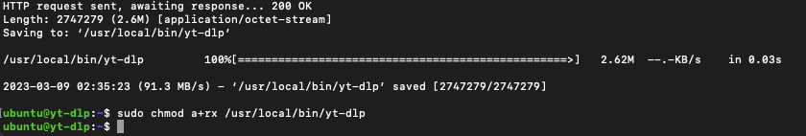

3. Installing Dependencies: FFmpeg and FFProbe
Before moving on with yt-dlp, it is highly recommended that you install FFmpeg and FFprobe. There are other ‘optional’ dependencies regarding the network, metadata, and miscellaneous, but FFmpeg and FFProbe are almost “mandatory”
- FFmpeg is a multimedia framework for handling video, audio, and other multimedia files. It is used by yt-dlp to perform various multimedia operations, including merging different formats of video or audio files. Without it, yt-dlp won’t be able to merge requested formats. For instance, you may download a 1080p video without audio.
- FFProbe is the command-line tool that comes with FFmpeg. FFProbe is used to analyze and extract information from multimedia files such as video and audio. Yt-dlp needs to use FFProbe to extract metadata from the multimedia files being downloaded. This metadata includes information such as the video or audio codec, the resolution, the duration, the bit rate, and other technical details about the multimedia file. Without FFprobe, yt-dlp would not be able to extract this metadata, and some of its features may not work correctly.
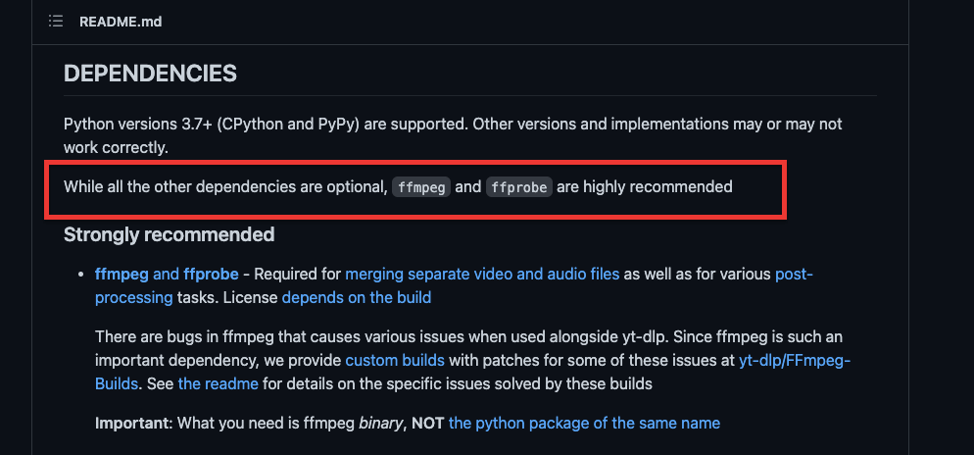
- Before installing FFmpeg and FFProbe, ensure that your machine is up to date.

a. Installing FFmpeg and FFprobe on Linux.
To install FFmpeg on a Linux machine (Ubuntu 22.04), use the following command:
1 | $ sudo apt install ffmpeg

- To check the installation and current version, use the following command:
1 | $ ffmpeg -version

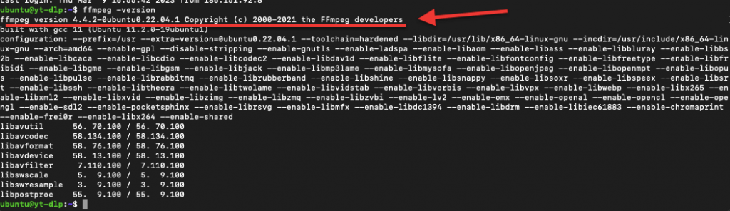
FFprobe installation? FFprobe comes when you install the FFmpeg package. There is no need to do additional installation for FFprobe. To test whether FFprobe is installed, issue the “ffprobe” command:
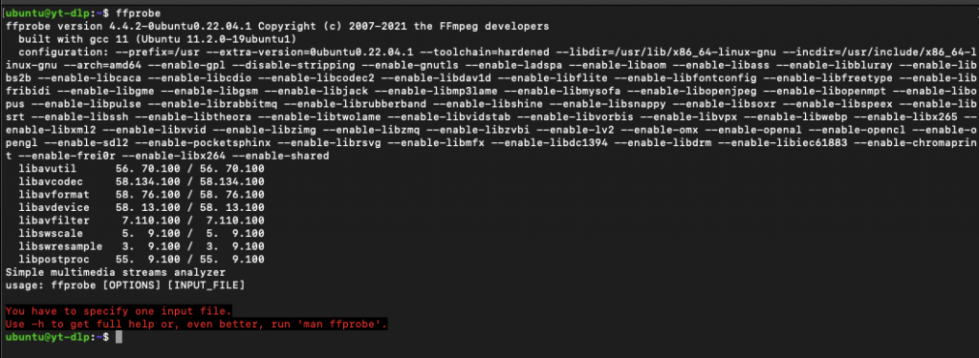

b. Installing FFmpeg and FFprobe on Windows
- Go to https://ffmpeg.org/ and download the package (.EXE file) for Windows. Release builds are usually more stable than Git Master build, which are released more often
- Choose your release, download the 7z or zip file and uncrompress it.
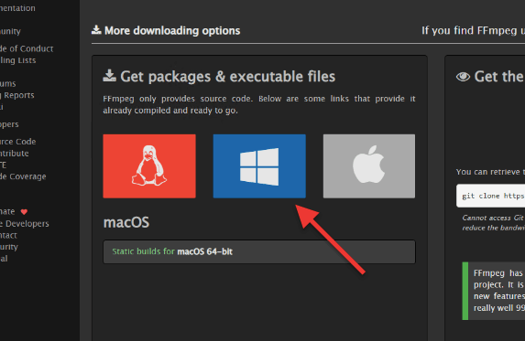
- Download the package and save it anywhere you want.
- We created a new folder called “PATH_Programs-ytdpl” where we will move and unzip the FFmpeg package.
- Under ffmpeg-(name of the file) > bin > you’ll see the three tools: ffmpeg, ffplay, and ffprobe. Move (unzip) the three applications to your new folder.
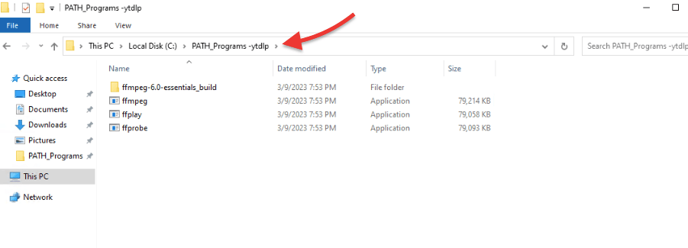
- Record the path (for example: C:\PATH_Programs -ytdlp) and head over to “Edit the system environment variables.” This Windows utility allows you to modify the environment variables that are used by the operating system and applications running on your computer. The PATH environment variable we will define next specifies a list of directories that the operating system should search when looking for executable files.
- To open this, go to the search bar on Windows and type “path”
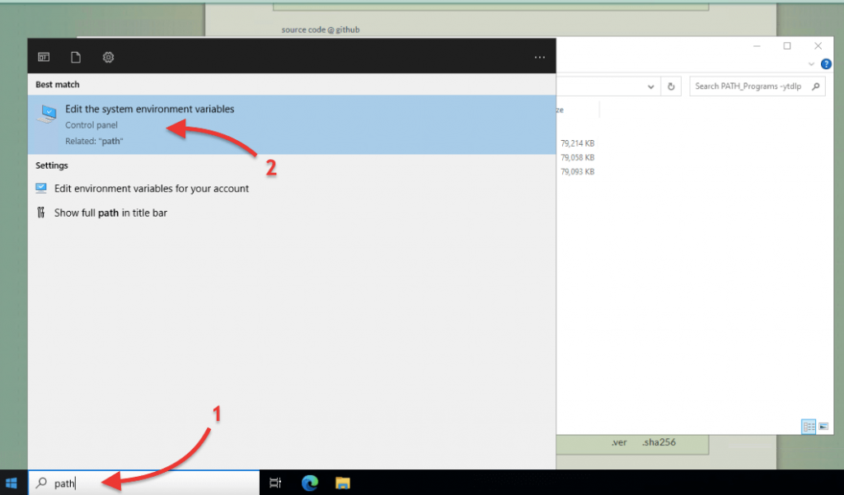
- In System Properties > Advanced, head over to “Environment Variables”
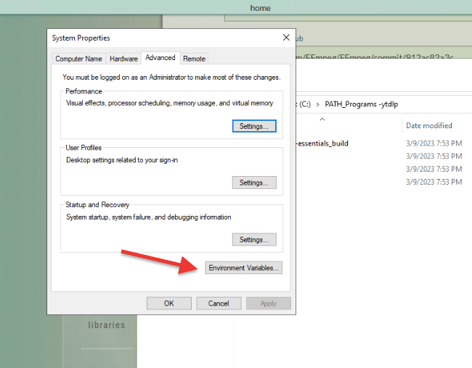
- In Environment Variables, under “User variables for Administrators” choose Path (1) > then click on “Edit”.
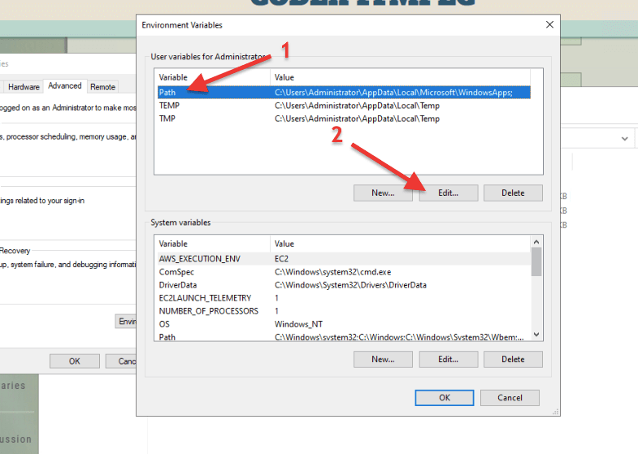
- The new “Edit Enviromnet variable” window will open. Click on New (1) > Enter the Path where FFmpeg is stored (2) > Click on Ok (3).
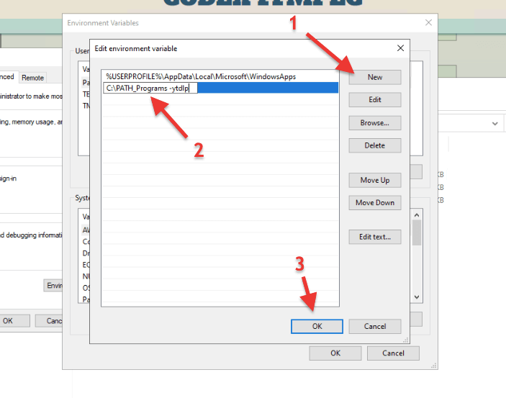
- Now, whenever you want to run FFmpeg from any folder or location, the computer will know where it is and allow you to use it.
- Now, test the FFmpeg configuration from the Windows command prompt. Open the “cmd” and type ‘ffmpeg’. You should get an output such as the one below.
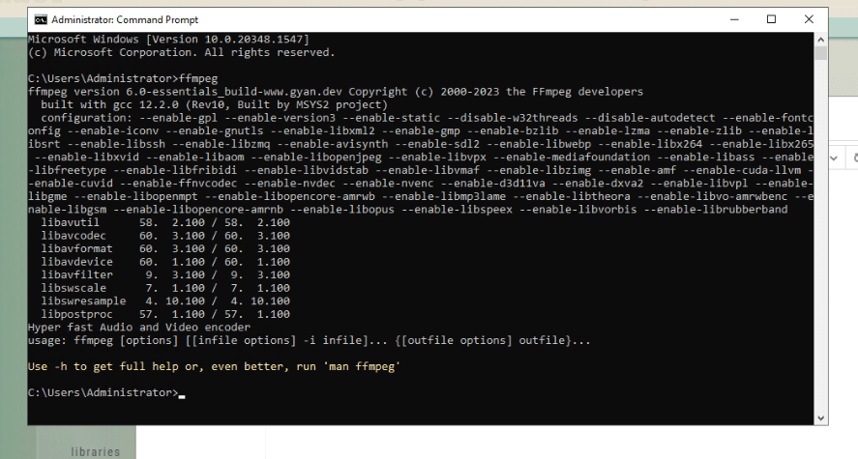
- FFprobe comes with the FFmpeg installation (as you might have noticed above). To test FFprove, do the same as ffmpeg. Simply go to the command prompt and type ‘ffprobe’.

4. How to use YT-DLP in Windows and Linux.
As you might already know, yt-dlp is a command-line tool, so to use it (in Windows or Linux), you will have to go thorugh the command prompt or terminal. If you have already downloaded, installed it along with its dependencies, go ahead and open your terminal.

a. How to use yt-dlp in Windows?
- Yt-dlp runs on the command line (it has no frontend GUI). When you run it from the cmd.exe for the first time (without any arguments), you will notice an error message (such as the following): “yt-dlp.exe: error: You must provide at least one URL”
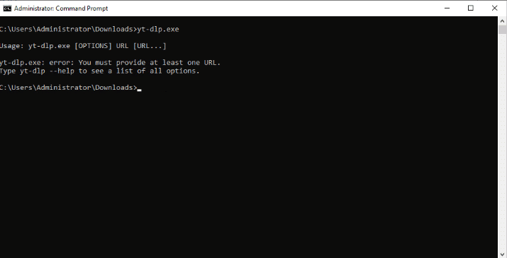
- Let’s go ahead and access the help menu. To see a list of all the options, use type the “yt-dlp –help” command. A menu such as the following will appear in your terminal (or command prompt):
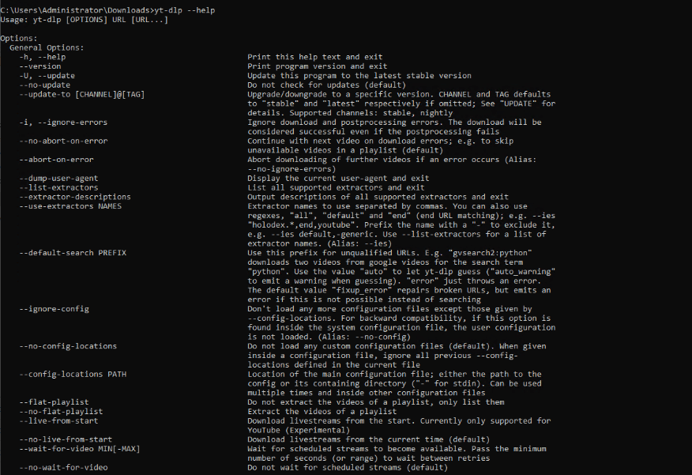
- To use yt-dlp, ensure you are in the same location where yt-dlp.exe is, and use it with “yt-dlp (following the youtube URL), for instance:
1 | yt-dlp https://www.youtube.com/watch?v=1PmJeP-TphM

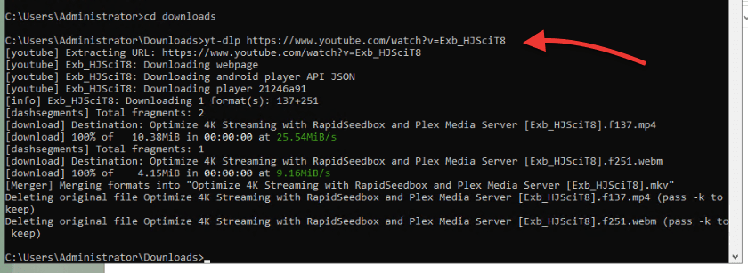
- Yt-dlp allows you to use arguments to empower you with more options when downloading your youtube videos.
- For example, you can tell yt-dlp exactly the format you want and how to download it. To do this, you might have to first find out what formats are available: Use the following command:
1 | &nbsp;yt-dlp -F --list-formats https://www.youtube.com/watch?v=1PmJeP-TphM

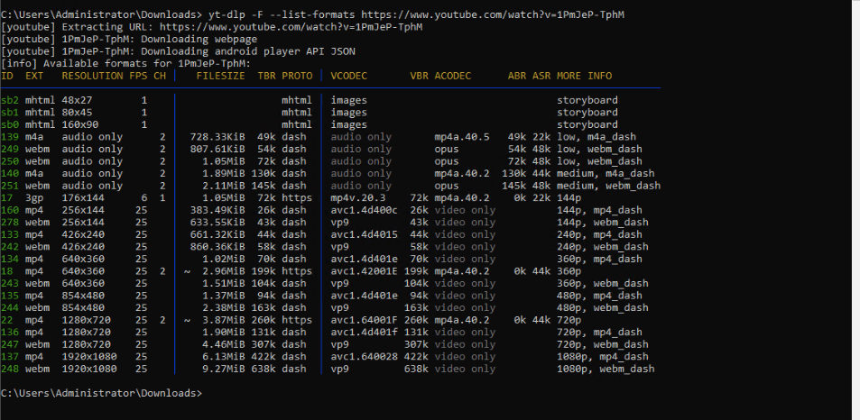
- Now, you might want to download a youtube video (i.e.https://www.youtube.com/watch?v=1PmJeP-TphM) with the format (-f) best quality video and best audio available (with specific format); to do this use the following command:
1 | yt-dlp -f "bestvideo&#91;ext=mp4]+bestaudio&#91;ext=m4a]" https://www.youtube.com/watch?v=1PmJeP-TphM

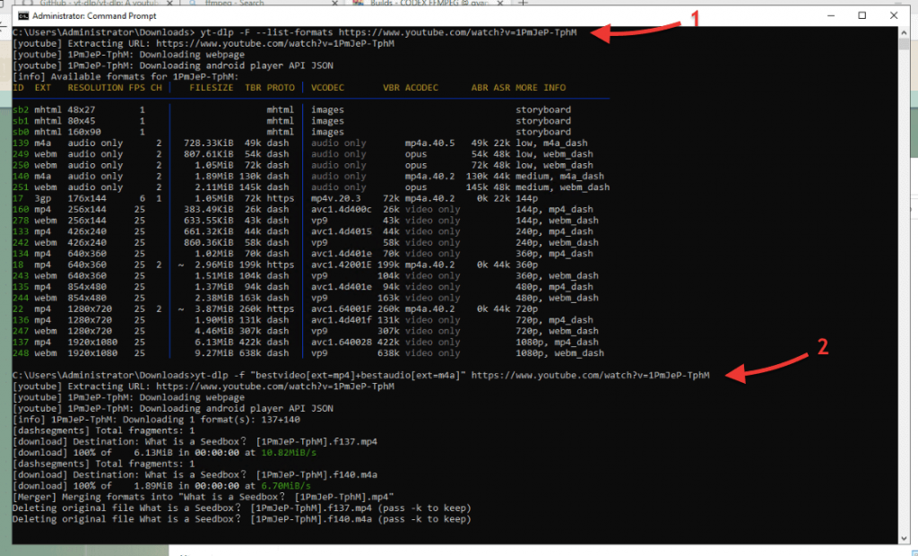
- To learn more about these arguments and how to use them properly, use the yt-dlp –help” command.
- And that’s it; we downloaded two youtube videos using yt-dlp.
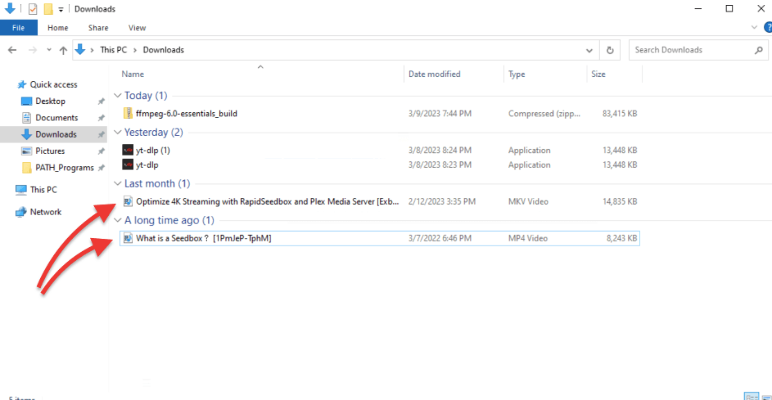

b. How to use yt-dlp in Linux?
- Same as Windows, in Ubuntu Linux, if you type yt-dlp [without arguments] in the terminal console, you’ll get an error message.
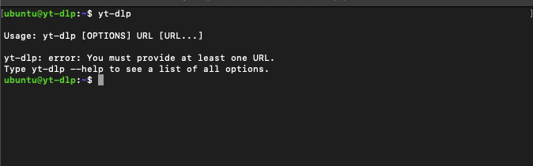
- If need to see the yt-dlp help menu, use the following command yt-dlp –help
- If you want to download a youtube video with the best quality video and best audio available, use the following command:
1 | yt-dlp -f 'bv*+ba' https://www.youtube.com/watch?v=1PmJeP-TphM

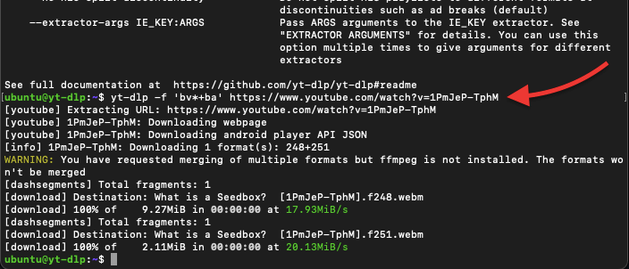
Note: If you see the following WARNING message: “You have requested merging of multiple formats (of video and audio), but FFmpeg is not installed. The formats won’t be merged.” it means that you have not yet installed FFmpeg… To learn how to install FFmpeg, go back to the section (installing FFmpeg).
- Now, what if you want to download a specific format for your youtube video? A useful Format command is the “-F –list-formats.” For example, we would like to list the available formats on the video >
1 | &nbsp;yt-dlp -F --list-formats https://www.youtube.com/watch?v=1PmJeP-TphM

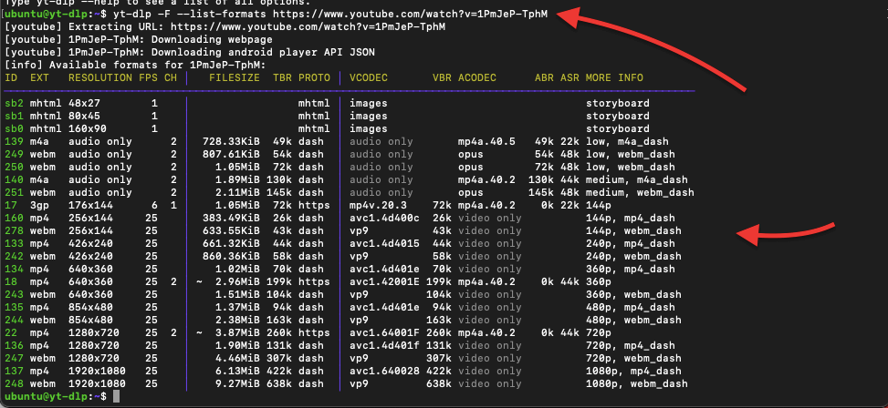
- For example, from the above output, you can see that this youtube video is available for download with video and audio at the resolutions 144p, 360p, and 720p. Now, let’s specify which format we want to download.
- We will use another video as an example. First (as shown before) see the available formats and then use the command “-f ‘bv*[height=…]+ba’” to specify the format. For instance,
1 | yt-dlp -F --list-formats https://www.youtube.com/watch?v=9jw9W7kUBFk

1 | yt-dlp -f 'bv*&#91;height=720]+ba' https://www.youtube.com/watch?v=9jw9W7kUBFk

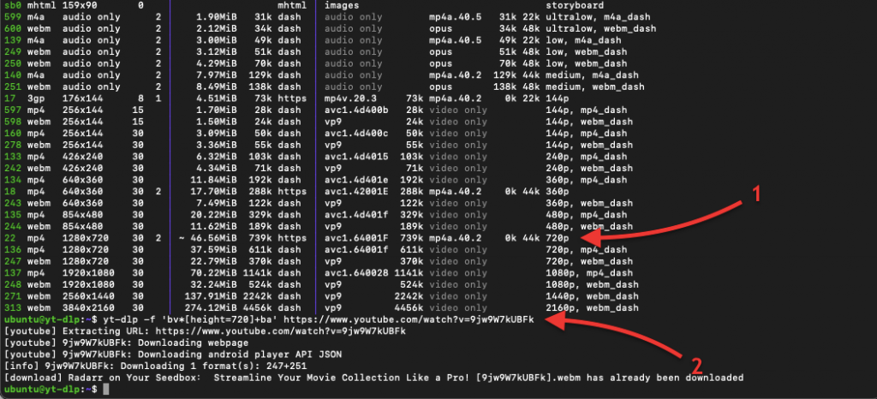
- Using the above set of commands will help you be more specific about which youtube video format you would want to download. Instead of downloading the highest (4K, for example), you can specify the audio and video format.
- In addition, you’ll notice that the FFmpeg WARNING message is not showing. This is because at this point, we already have installed FFmpeg correctly.

5. Advanced uses for Plugin yt-dlp.
Below we will show you two more advanced uses for the yt-dlp plugin. We will show you these examples on Linux.

a. Configuring the yt-dlp.conf file.
The plugin yt-dlp also offers the option to establish a range of defaults that it will automatically implement, including a preferred video format such as mkv, mp4, webm, etc. To create a configuration file that yt-dlp can use, enter supported commands into the configuration file. The config file can be loaded from the system (/etc/yt-dlp.conf), user configuration, home configuration, portable or main configuration.
- Open (or create) the yt-dlp.conf from your terminal using the text editor:
1 | sudo vim /etc/yt-dlp.conf

- Or
1 | sudo vi /etc/yt-dlp.conf

- The below configuration file is an example (but you can customize it to your own preferences). Using the below configuration, yt-dlp will automatically save all videos in a particular path (/Youtube) and renames them to the Title.extension. By default, yt-dlp saves youtube videos to its default path and gives the URL as the main title.
The configuration will also embed a thumbnail, metadata, and English subtitles.
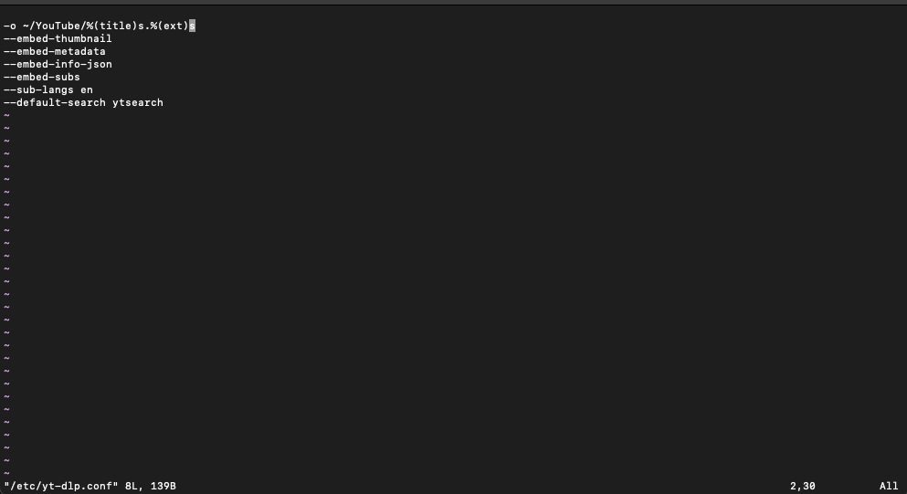
- Now let’s try our brand new yt-dlp configuration:
1 | yt-dlp https://www.youtube.com/watch?v=z8HY1aVzZDM

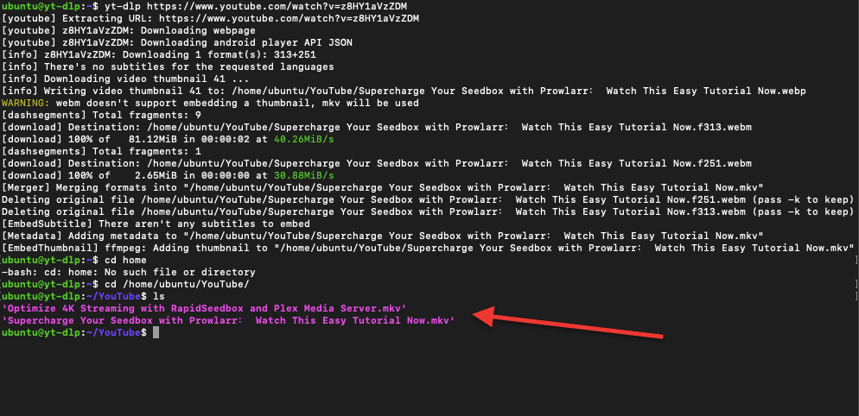
With this configuration file, you can automate your entire youtube download process. This saves you time, as you no longer have to enter configuration for each line of video download. The configuration file will use your personalized download format for the process.
Note (For Windows users): It is recommended to put this config file in “${APPDATA}/yt-dlp/config” and save it as .txt. The AppData folder is under “C:\Users\<user name>\AppData\” and is usually a hidden folder. Setting configuration lines in this config file is similar to what we did with Linux in this section.

b. Use Bashrc files.
Another way you can optimize your download process with yt-dlp is to use bashrc files. These files contain shell (command-line interface) settings for the Bash shell. The bashrc file is executed every time a new terminal session is opened, and it can be used to configure various settings and aliases for the shell. The bashrc file can be very useful for yt-dlp, because you can use it to set up aliases or shell functions that simplify the usage of yt-dlp. For example, you can create an alias that automatically downloads a video in your preferred format and quality by typing a single command in the terminal. This can save you time and make it easier to use yt-dlp regularly.
- To locate the .bashrc (in Ubuntu) go to home/ubunu > .bashrc
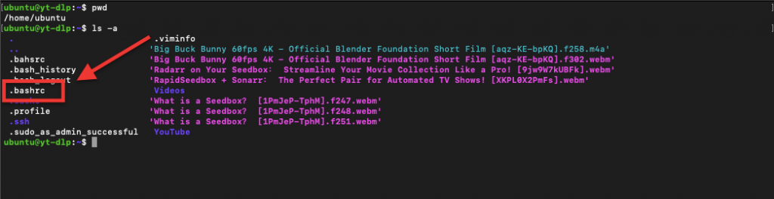
- Open the .bashrc with any of the following text editors.
1 | sudo vi ~/.bahsrc

Or,
1 | sudo nano ~/.bahsrc

- Enter the bashrc aliases for yt-dlp that you would like. For example:
1  2  3  4 | # yt-dlp aliases  alias ydl='yt-dlp'  alias ydlmp4='yt-dlp -f "bestvideo&#91;ext=mp4]+bestaudio&#91;ext=m4a]/best&#91;ext=mp4]/best"'  alias ydlmkv='yt-dlp -f "bestvideo&#91;ext=mkv]+bestaudio&#91;ext=mka]/best&#91;ext=mkv]/best"'

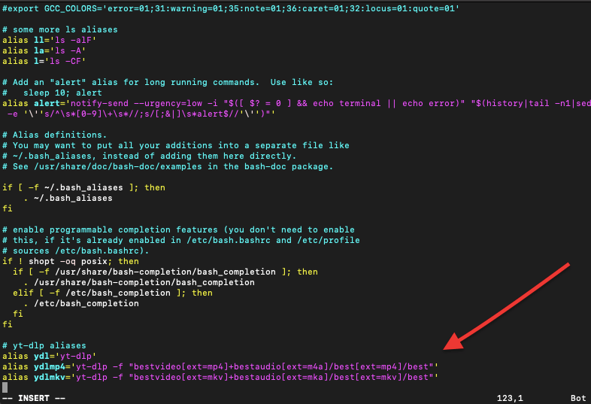
- To activate the aliases, either close and reopen the terminal window or run the following command:
1 | $ source ~/.bashrc

- Now, let’s test our alias. This should make our lives easier when downloading youtube videos with yt-dlp. Use an alias; for example, by entering “ydlmp4” you are saving yourself on writing long commands such as bestvideo[ext=mp4]+bestaudio[ext=m4a]/best[ext=mp4]/best
- There are many things happening now! As you can see from the below output… Our alias is working, the configuration is trying to embed thumbnails, subtitles, metadata, etc. Plus, the video is being saved in (and with) /Youtube/%(title)s.%(ext)s – where the title is the name of the video rather than the URL.
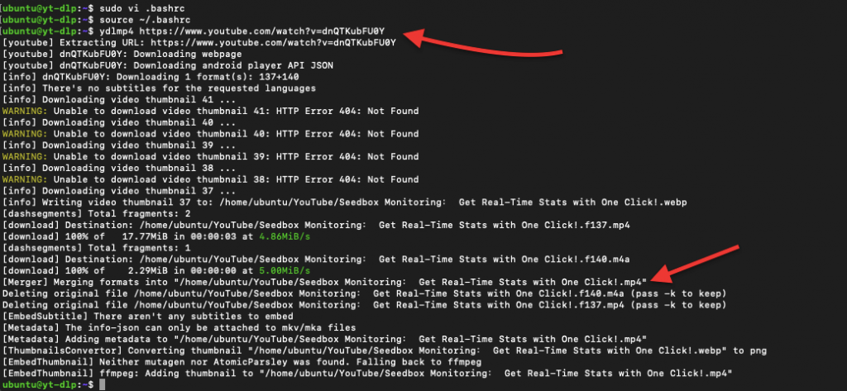

c. Manage and download large amounts of data with yt-dlp into a seedbox.
If you download and manage large amounts of data with yt-dlp, then a seedbox can be a fantastic solution. A seedbox is a remote VPS or dedicated server designed for anonymous download and upload of digital files, such as torrents, NZBs, videos, and music. Plus, since seedboxes are designed for downloading and uploading, they usually offer high speeds.
For instance, you can remotely connect to your seedbox and use its powerful resources to download videos with yt-dlp. Seedboxes also offer streaming platforms like Plex or Kodi and other wonderful ways to manage your media collection. Plus, if you decide later to change the format, compress, or encode, seedboxes also come with robust media converters like Handbrake. You can later download all your media content easily with FTP or Sync protocols.
This combination allows fast and efficient downloads and easy management of all your downloaded content.

6. yt-dlp: Pros and Cons
Although yt-dlp has many great features and characteristics that make it one of the best youtube downloaders, it also has a few disadvantages that you should know about. Here are some pros and cons of using yt-dlp.

a. Pros:
- Free and open-source: yt-dlp is 100% free. It is also an open-source project maintained by a solid community of developers.
- Multi-platform support: yt-dlp is available for Windows, Linux, and macOS. This multi-platform support makes it accessible to a wide range of users.
- Variety of download options: Although yt-dlp is one of the best for what it does, “download youtube videos,” it also has additional options that are hard to see in other video downloaders. These download options include video format, subtitle selection, and thumbnail images.
- Automatic retries: yt-dlp has some fantastic automation capabilities. One of the best features it that it can automatically retry failed downloads, saving you time and effort.
- Support for more sites and extensions: yt-dlp supports more sites other than youtube, including Vimeo and Youku. It also supports browser extensions like SponsorBlock, to allow you to skip sponsored segments in YouTube videos.

Cons:
- No GUI: One turndown for many people when using yt-dlp is the lack of GUI. yt-dlp is a command-line tool, which may not be ideal for users who prefer a graphical user interface.
- Configuration required: As you might have noticed from our step-by-step guide to configure and use yt-dlp, the tool requires some knowledge for its configuration. To use yt-dlp, you must learn the configuration lines to get the desired output format, audio quality, or other options.
- No official packages: yt-dlp does not have official packages for some platforms. If you have the skills and the patience to build it from a source or rely on third-party repositories, then having no official package may not disadvantage you.
- Legal concerns: Downloading Youtube videos is technically against their Terms of Service. So literally, the company could sue you. Still, many users decide to do so, and the company has shown no desire to penalize users for downloading their videos. However, it is still vital for you to be aware of the legal implications of downloading copyrighted material.

7. YT-DLP: FAQ.
Q: What are the advantages of using yt-dlp over youtube-dl?
A: yt-dlp offers additional features and options not available in youtube-dl. It also has an active development community that ensures that bugs are quickly fixed, and new features are added. Check our previous section: Pros & Cons.
Q: How do I install yt-dlp?
A: You can install yt-dlp on Linux, Windows, or macOS by downloading the binary executable file or by installing it via your operating system’s package manager. To learn how to install yt-dlp, go back to the “how to download and install yt-dlp” section
Q: Can I download videos in different formats using yt-dlp?
A: Yes, you can download videos in different formats using yt-dlp. You can specify the format using command-line options or editing the configuration file.
Q: Is it legal to use yt-dlp to download Youtube videos?
A: Some content on YouTube may be copyrighted, and downloading it without permission may be illegal. Downloading videos from Youtube is against’s Youtube ToS. But still, many people do so, and Youtube has decided to take no action.
Q: Can I download entire playlists with yt-dlp?
A: Yes, yt-dlp lets you download entire playlists by specifying the playlist’s URL.
Q: Does yt-dlp support subtitles?
A: Yes, yt-dlp supports subtitles in various formats. You can embed subtitles in your downloads and specify the preferred subtitle language.
Q: Can I download audio-only files using yt-dlp?
A: Yes, yt-dlp allows you to download audio-only files in various formats, such as MP3 and AAC.
Q: Is yt-dlp actively maintained?
A: Yes, yt-dlp is actively maintained by a team of professional developers who regularly release updates and bug fixes.

8. Final Words.
In conclusion, yt-dlp is a powerful and feature-rich video downloader. It has become the best alternative to the old-time popular youtube-dl plugin. With its extensive list of options and support for various formats and video sites, it’s no wonder why yt-dlp is the leading youtube downloader platform.
If you haven’t already, we encourage you to try yt-dlp. You’ll quickly see why yt-dlp is becoming the go-to choice for downloading videos.
We suggest contacting the yt-dlp project’s maintainer on GitHub if you encounter any issues or have suggestions for new features. But if you have any questions or suggestions about this yt-dlp guide, please let us know in the comments box below.
So what are you waiting for? Start downloading today!

